Skyline Pop Top Price List 2021/22
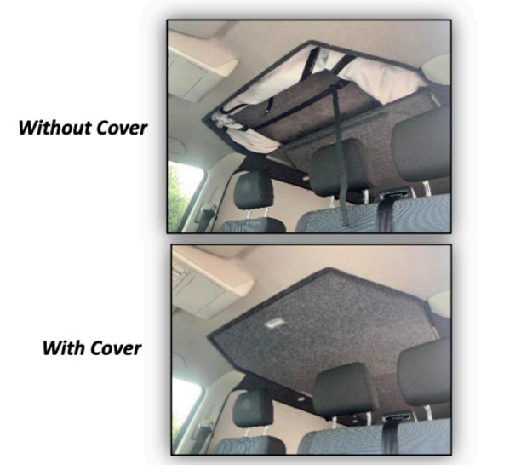
(All prices include VAT at 20%)

Skyline roofs have full safety testing and TUV approval for T5/T6 roofs and Transit Customs.

Roof:
SWB T5/T6 Gloss Black or White Roof £2850

SWB Gloss Black or White Transit Custom Roof £3200

SWB T5/T6 Aurora Gloss Black or White Roof £3300

LWB T5/T6 Aurora Gloss Black or White Roof £3550

Mattresses, carpeting and bed boards are not included in the above pricing.
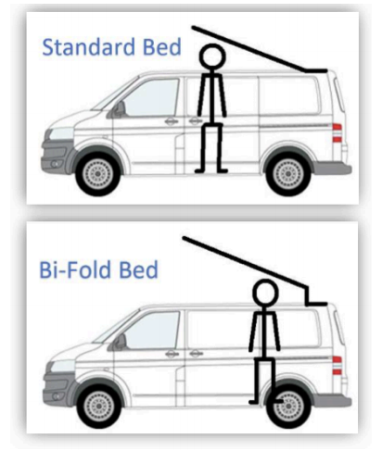
Beds:
Standard Bed Board on Gas Rams - Carpeted £300
Bi Fold Bed On Gas Rams - Carpeted £375

Extras:
Scenic opening canvas £200
Sliding Cover Panel - Carpeted £120
Mattress £80
Colour Coding £200
Thermal Wrap SWB £260
Thermal Wrap LWB £275
Mattress £80
Trimming of Metal Work (essential):
T5/T6 £175
Transit Custom £375 Caravelle/Shuttle £700

